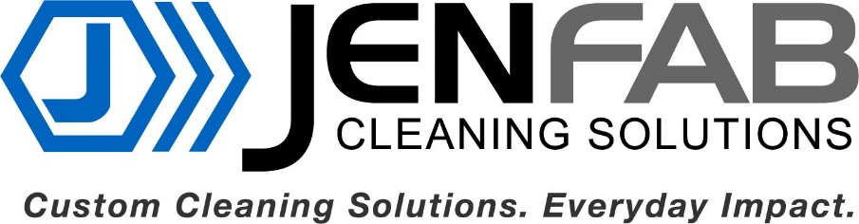

Jenfab Cleaning Solutions
Headquartered in Springfield Missouri, Jenfab manufactures automated parts washers for a broad line of industrial customers to include the military and those that serve them. We lead the way in the innovation and development of parts washers that meet the ever-changing needs of our customers. Today, we carry on our tradition of excellence in everything we do. We create Custom Cleaning Solutions with Everyday Impact.
How We Help Transitioning Rangers
Service with the Ranger Regiment is formative. Your training today will lead to success tomorrow on the battlefield, the shop floor or the board room. Jenfab is led by Jim Chew, CEO & President, and a former member of the Ranger Regiment. We understand that fabrication skills and business acumen is knowledge that can be learned. Here at Jenfab we believe our employees are our most important asset and we are willing and want to develop talent! Our culture is based on having each other’s back as One Team with a bias for action to improve our operation every day. At Jenfab, you will work alongside fellow veterans, first responders and citizens intent on bettering themselves. Our training program is led by a former Navy Master Chief and built on familiar tasks, conditions and standards format. Along with hiring transitioning veterans, we also mentor transitioning veterans and active-duty military considering a change. We are committed to providing and maintaining a work environment that promotes teamwork and employee engagement.
What do we expect from you?
Bring your commitment to the Ranger Creed to our business. We want your tenacity to shoulder more than your fair share of the task and complete the mission. We want your leadership skills. The Ranger DNA cannot be taught. We can teach you the technical skills you will need to succeed.

How to Connect with Jenfab
E-mail: hr@jenfab.com or jchew@jenfab.com
Check us out: www.jenfab.com
Follow us on LinkedIn: https://www.linkedin.com/company/jenfabcleaningsolutions/mycompany/

